Lecturer’s name: N/A | Date: Day 3
Course: Math 6 | Unit:Ordering Fractions, Decimals and Integers
Unit Duration: 5 days | Lesson Duration: 2 days
TEKS: 6.1A, 6.1C, 6.1D, 6.1E, 6.1F, 6.1G, 6.2A, 6.2C | Lesson Part #1
Topic: Introduction to Integers and Whole Numbers

Lesson objectives:
- SWBAT to order negative and positive fractions and decimals and integers
- SWBAT to understand that the further to the left on a number line, the smaller the values are
- SWBAT to understand the further to the RIGHT on a number line, the larger the values are

Essential Questions:
- How do I order integers, fractions and decimals?
- How do I convert them all to the same form?

LYS Methodology
Be (Character/Values/Principles) - Educational and Vocational - How will ordering integers help me to be a driven and disciplined individual?

Know (What resources are available to the student/ How can they use them) - Educational and Financial - Why is it important to understand integers and whole numbers especially when dealing with money management? Why is it also important to understand the difference between both terms as they do not mean the same thing.

Do (Execute with Excellence) - Educational, Cultural, Spiritual - How does learning about order with negative and positive values help me with resource management and independence?

Resources (Include Technology):
Instructional Input - Asynchronous
AS: Anticipatory Set (Introduction)
- Students complete activity ordering SIMPLE integers, fractions and decimals
- Order from Least to Greatest
  - -½ , 0 , -4 , 2.1 , 5
  - 0.25, -12, 7, 6.6, ⅕

M: Modeling (I do) #1
- Rigor has increased in the types of questions so modeling 1 will be important to walk student through the steps and EXPLAIN aloud the thought process
- TM:
- 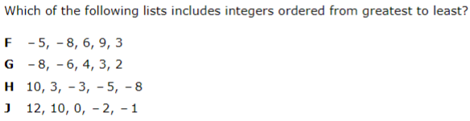

- Practice:
- 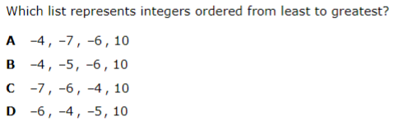

GP: Guided Practice (We do)
- Students will complete online activity on how to order fractions and decimals
- Ordering Fractions and Decimals - MC Practice

Instructional Input - Synchronous
AS: Anticipatory Set (Introduction)
- Students complete activity ordering SIMPLE integers, fractions and decimals
- Order from Least to Greatest
  - -½ , 0 , -4 , 2.1 , 5
  - 0.25, -12, 7, 6.6, ⅕

M: Modeling (I do) #1
- Rigor has increased in the types of questions so modeling 1 will be important to walk student through the steps and EXPLAIN aloud the thought process
- TM:
- 

- Practice:
- 

GP: Guided Practice (We do)
- Students will complete online activity on how to order fractions and decimals
- Ordering Fractions and Decimals - MC Practice

Independent Practice/ Homework
- Converting fractions to decimal and back practice

Additional Practice
- Comparing fractions and decimals with less than/greater than + Answer Key

Lesson Close

Being able to convert between fractions, decimals, and percentages is an essential skill as it greatly develops a student's concept of what the quantities mean. It also makes fractions and percentages of amounts much simpler to visualize and compare. Not only are students being taught to understand quantities and how they are related to one another, they are then being pushed to think of the amount of time or money being invested in certain interests.

Ordering and comparing creates a more disciplined life as it teaches students how to convert certain values to the same form. This also helps students understand that spending 30 min watching TV is just the same as spending 30 min reading a book and how each of these activities bring value to their lives.

